KATHEKA BOYS SECONDARY SCHOOL
Name: …………………………………………………………… Adm No: ………………………………
School: …………………………………………………………. Class ……………..…………………….
Date: ………………………………………………………….

BIOLOGY

TIME: 2 HOURS

Biology
FORM 1

INSTRUCTIONS TO THE CANDIDATES:-

- Write your name and Admission number in the spaces provided.
- Answer all the questions in the spaces provided.
- Mathematical tables and electronic calculators may be used
- All working MUST be clearly shown where necessary.

For Examiner’s Use Only:

Question | Maximum score | Candidate’s score
1-19 | 100 MARKS

- What is biology? (1mk)
…………………………………………………………………………………………………………………..
…………………………………………………………………………………………………………………..
- List five skills that are gained by studying Biology. (5mks)
…………………………………………………………………………………………………………………..
………………………………………………………………………………………………………………………………..…………………………………………………………………………………………………………………..………………………………………………………………………………………………………………………………………………………………………………………………………………………..
- Biology is derived from two Greek words bios and logos. What is the meaning of
Bios (1mk)
…………………………………………………………………………………………………………………..
Logos (1mk)
…………………………………………………………………………………………………………………..
- List three main branches of biology and for each give its definition (6mks)
…………………………………………………………………………………………………………………..
…………………………………………………………………………………………………………………..
…………………………………………………………………………………………………………………..
- State and explain any five characteristics observed among living organisms (10mks)
…………………………………………………………………………………………………………………..
…………………………………………………………………………………………………………………..
…………………………………………………………………………………………………………………..
…………………………………………………………………………………………………………………..
…………………………………………………………………………………………………………………..
…………………………………………………………………………………………………………………..
…………………………………………………………………………………………………………………..
…………………………………………………………………………………………………………………..
…………………………………………………………………………………………………………………..
…………………………………………………………………………………………………………………..

- Identify the following apparatus and for each state the function (6mks
(a) 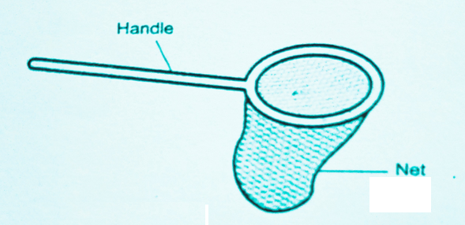
Name
…………………………………………………………………………………………………………………..
Function
…………………………………………………………………………………………………………………..
(b)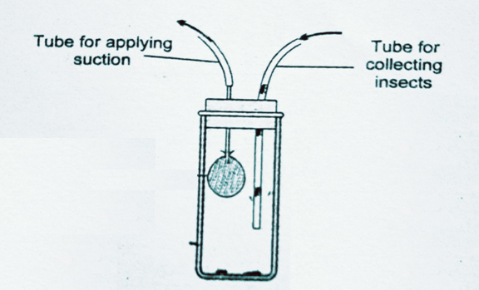
Name
…………………………………………………………………………………………………………………..
Function
………………………………………………………………………………………………………………….
(c) 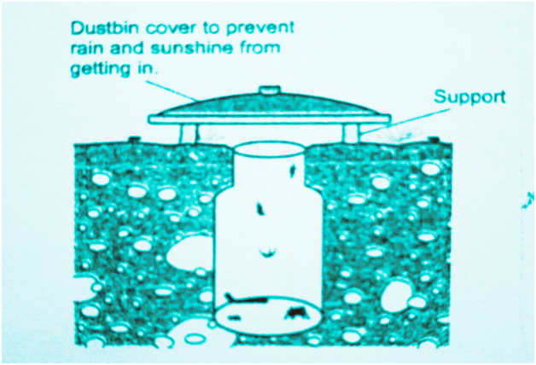
Name
…………………………………………………………………………………………………………………..
Function
…………………………………………………………………………………………………………………..
- Outline the four precautions to be observed during collection and observations of organisms during practical study. (4mks)
…………………………………………………………………………………………………………………..
…………………………………………………………………………………………………………………..
…………………………………………………………………………………………………………………..
…………………………………………………………………………………………………………………..
…………………………………………………………………………………………………………………..
…………………………………………………………………………………………………………………..
- The diagram below shows an instrument used in the laboratory
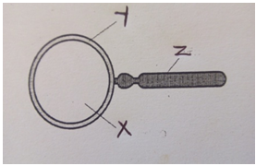
(a) Name the instrument (1mk)
…………………………………………………………………………………………………………………..

- Label the parts (3mks)
X
…………………………………………………………………………………………………………………..
Y
…………………………………………………………………………………………………………………..
Z
…………………………………………………………………………………………………………………..
- What is the function of the instrument?(1mk)
…………………………………………………………………………………………………………………..
…………………………………………………………………………………………………………………..

- The student observed the housefly whose actual length was 8cm. she used the apparatus named above 6(a) above and the total magnification was X4. Calculate the length of the drawing. Show your working. (3mks)
…………………………………………………………………………………………………………………..
…………………………………………………………………………………………………………………..
…………………………………………………………………………………………………………………..
…………………………………………………………………………………………………………………..…………………………………………………………………………………………………………………..
- (a) What is classification? (1mk)
…………………………………………………………………………………………………………………..
…………………………………………………………………………………………………………………..
(b) State four importance of classification of living organisms? (4mks)
…………………………………………………………………………………………………………………..
…………………………………………………………………………………………………………………..
…………………………………………………………………………………………………………………..
…………………………………………………………………………………………………………………..

- Fill the table below by identifying the correct kingdom and appropriate representative in each case (5mks)
Kingdom | Representative
a) | cow
b) | Protozoa
c) | Yeast
d) Monera
e) | Garden pea

- Distinguish between magnification and resolution (2mks)
…………………………………………………………………………………………………………………..
…………………………………………………………………………………………………………………..
…………………………………………………………………………………………………………………..

- Fill the table below (3mks)
Eye-piece lens | Objective lens | Total magnification
X30 | (i) ………………………………. | X600
X14 | X5 | (ii) ………………………………
(iii) ……………………… | X40 | X2000

- Give any four external features in animals which can be used for classification (4mks)

- Distinguish between unicellular and multicellular organisms. (2mks)
…………………………………………………………………………………………………………………..
…………………………………………………………………………………………………………………..
…………………………………………………………………………………………………………………..
- State any three precautions to be taken when handling a microscope. (3mks)
…………………………………………………………………………………………………………………..
…………………………………………………………………………………………………………………..
…………………………………………………………………………………………………………………..

- The figure shows a microscope
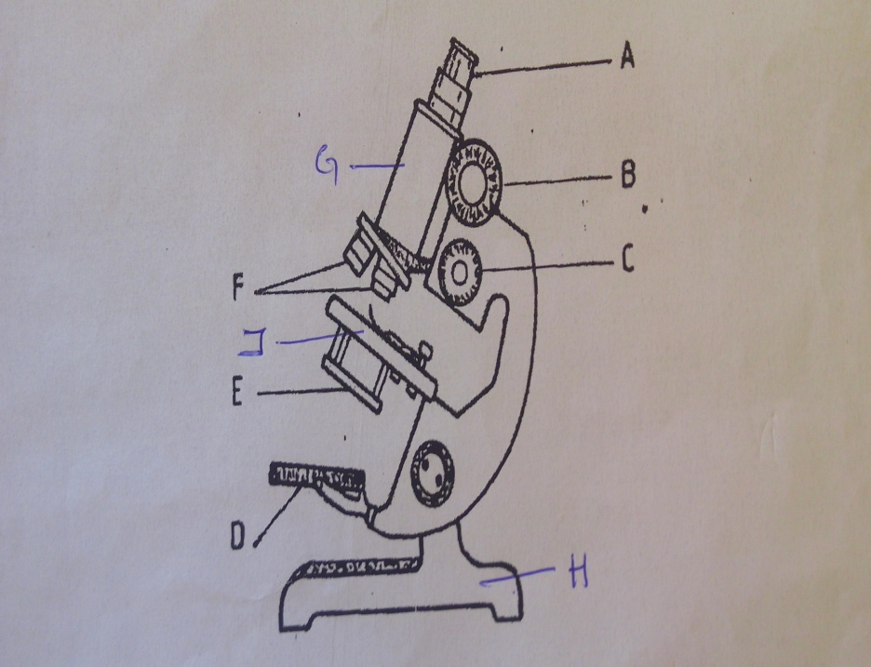
- Name the parts of the microscope shown below. (4mks)
A
…………………………………………………………………………………………………………………..
C
…………………………………………………………………………………………………………………..
J
…………………………………………………………………………………………………………………..
D
…………………………………………………………………………………………………………………..
- State the functions of the parts (5mks)
B
…………………………………………………………………………………………………………………..
…………………………………………………………………………………………………………………..
E
…………………………………………………………………………………………………………………..
…………………………………………………………………………………………………………………..
F
…………………………………………………………………………………………………………………..
…………………………………………………………………………………………………………………..
G
…………………………………………………………………………………………………………………..
…………………………………………………………………………………………………………………..
H

- State three importance of studying biology (3mks)
…………………………………………………………………………………………………………………..
…………………………………………………………………………………………………………………..
…………………………………………………………………………………………………………………..
- For the table below, give five differences between light and Electron microscope (5 mks)
Light microscope | Electron microscope
- (a) What is the name given to the double naming of living organisms? (1mk)
…………………………………………………………………………………………………………………..
…………………………………………………………………………………………………………………..
(b) The scientific name of a cat is Felis catas. Which taxonomic group does the name Felis and catas refer to? (2mks)
Felis:…………………………………………

Catas:……………………………………………

(c) Outline four principles used in double naming system of living organisms (4mks)
………………………………………………………………………………………………………………..
…………………………………………………………………………………………………………………..
…………………………………………………………………………………………………………………..
…………………………………………………………………………………………………………………..
…………………………………………………………………………………………………………………..
…………………………………………………………………………………………………………………..

19.State any four difference between plants and animals (4mks)
Plants | Animals
20.The table below show the seven taxonomic ranks .Fill the missing gaps in the table below(5mks)

*******
species
kingdom

